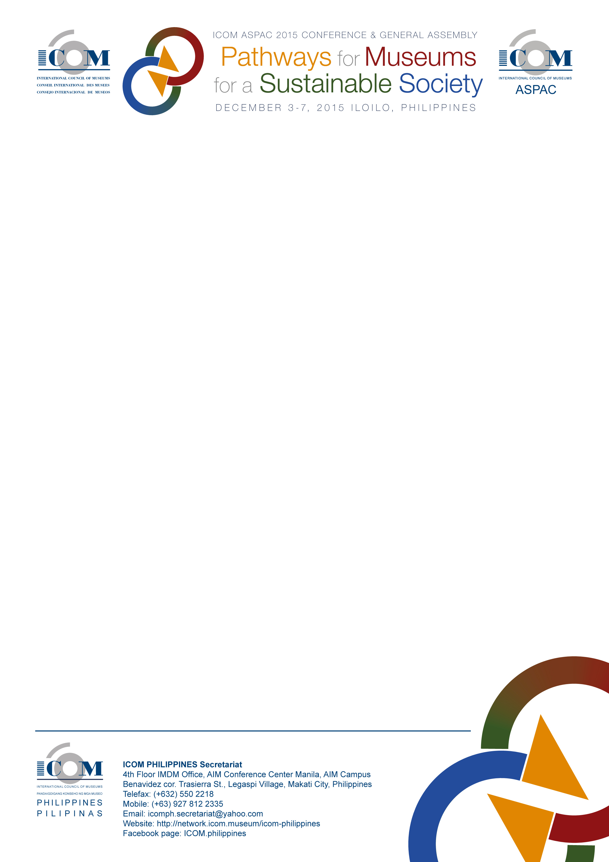**International Council of Museums-Philippines and the ICOM-Asia Pacific Organization present**

**ICOM-ASIA-Pacific 2015 Conference and General Assembly**

on the Theme: “Pathways for Museums for a Sustainable Society”

3-7 December 2015

Iloilo Convention Center, Iloilo City, Panay Island, Central Philippines

**REGISTRATION FORM**

|  |  |  |  |
| --- | --- | --- | --- |
| Full Name First | | Middle | Last |
| Preferred Name on Conference ID/ Badge | | | Birthdate |
| Title/ Position | | | Gender |
| Institution/Company Name | | | |
| ICOM Membership number (Please indicate if Institutional or Individual) | | | |
| Country | | | Zip Code |
| Email Address | Mobile Number | | Office Contact Number |
| Signature |  | |  |
| **Please send your accomplished registration form via any of the following modes: Fax (63)(2) 550-2218, Email** [**icomph.secretariat@yahoo.com**](mailto:icomph.secretariat@yahoo.com)**or deliver to ICOM Philippines Secretariat Postal Address (see below).** | | | |



|  |  |  |
| --- | --- | --- |
| **Details for Billing Statement**  (If different from the address on the registration form)  **ICOM-Asia Pacific Organization 2015**  **Conference and General Assembly on**  Pathways for Museums and Sustainable Societies  3-7 December 2015, Iloilo Convention Center, Iloilo City, Panay Island, Central Philippines |  | **Payment Instructions**  Payment may be made in cash or in cheque* to:  **Acct Name: International Council of Museums –Philippines, Inc.**  **Acct Number: 1571-0008-45**  **Name of Bank: BPI**  Kindly fax or email (scanned/clear photo) the deposit slip to Telefax (632) 550.2218 or [icomph.secretariat@yahoo.com](mailto:icomph.secretariat@yahoo.com) once payment has been made. Please indicate the participant’s name in the deposit slip. Official Receipt will be issued upon receipt of the copy of deposit slip.  *For cheque payment, a provisional receipt will be issued for reference purposes. Official receipt will be issued once the cheque has been cleared  Once payment is received and confirmed within deadlines, you will be assured of a seat at the ICOM-ASPAC 2015 Conference & General Assembly.  The Registration Fee includes the following:   * Four (4) day participation at the entire conference with study tours. * Coffee breaks and lunches during the two (2) day conference-proper * Access to Welcome Reception and Farewell Reception, Events/Socials * Participant kit (Summit bag)   The Registration Fee does NOT include pre-conference and post conference tours, inland transportation, and travel to Iloilo City. |
|  |  |
| Contact Person (First, Middle, and Last Name) |  |
| Institution/ Company Name |  |
| Address |  |
| Country |  |
| Contact Numbers |  |
| Email Address |  |
|  |
|  |
|  |

**Payment Details and Registration Fee**

|  |  |
| --- | --- |
|  | **Regular Registration**  **Rate**  ***(November 1 – Conference Day)*** |
| **Local Fee** | PhP5,000 |
| **Registration by Group\***   * **Local** | PhP 4,500 |

***\*Group of 3 attendees from the same institution/company Please communicate directly with Ms. Mitch Rico at (550-2218) and send your certification document from your ICOM-NC and ICOM Secretariat in Paris***